FREQUENCIES VARIABLES=Pre_Control Post_Control Pre_Experiment Post_Experiment
/NTILES=4
/STATISTICS=STDDEV VARIANCE MINIMUM MAXIMUM SEMEAN MEAN MEDIAN MODE SUM SKEWNESS SESKEW KURTOSIS SEKURT
/HISTOGRAM NORMAL
/ORDER=ANALYSIS.

Frequencies

Notes
Output Created |  | 10-APR-2023 11:45:53
Comments
Input | Data | D:\Data Abah\Aktivitas 2023\Data Bu Kartini\Data Penelitian Ibu Kartini\Uji Normalitasi Pre dan Post.sav
Input | Active Dataset | DataSet1
Input | Filter | <none>
Input | Weight | <none>
Input | Split File | <none>
Input | N of Rows in Working Data File | 32
Missing Value Handling | Definition of Missing | User-defined missing values are treated as missing.
Missing Value Handling | Cases Used | Statistics are based on all cases with valid data.
Syntax |  | FREQUENCIES VARIABLES=Pre_Control Post_Control Pre_Experiment Post_Experiment  /NTILES=4  /STATISTICS=STDDEV VARIANCE MINIMUM MAXIMUM SEMEAN MEAN MEDIAN MODE SUM SKEWNESS SESKEW KURTOSIS SEKURT  /HISTOGRAM NORMAL  /ORDER=ANALYSIS.
Resources | Processor Time | 00:00:00.13
Resources | Elapsed Time | 00:00:00.37

Statistics
 |  | Pre_Control | Post_Control | Pre_Experiment | Post_Experiment
N | Valid | 27 | 27 | 32 | 32
N | Missing | 5 | 5 | 0 | 0
Mean |  | 41.6111 | 66.7885 | 42.4969 | 81.4581
Std. Error of Mean |  | 2.20425 | 1.46161 | 1.22514 | 1.32977
Median |  | 40.0000 | 66.6700 | 41.6500 | 81.6650
Mode |  | 46.70 | 60.00ª | 33.30 | 86.67
Std. Deviation |  | 11.45363 | 7.59476 | 6.93046 | 7.52231
Variance |  | 131.186 | 57.680 | 48.031 | 56.585
Skewness |  | .053 | .394 | .143 | -.030
Std. Error of Skewness |  | .448 | .448 | .414 | .414
Kurtosis |  | -1.102 | -.774 | -1.320 | -1.196
Std. Error of Kurtosis |  | .872 | .872 | .809 | .809
Minimum |  | 23.30 | 56.67 | 33.30 | 70.00
Maximum |  | 60.00 | 80.00 | 53.30 | 93.33
Sum |  | 1123.50 | 1803.29 | 1359.90 | 2606.66
Percentiles | 25 | 30.0000 | 60.0000 | 36.7000 | 74.1650
Percentiles | 50 | 40.0000 | 66.6700 | 41.6500 | 81.6650
Percentiles | 75 | 53.3000 | 70.0000 | 49.1750 | 86.6700
a. Multiple modes exist. The smallest value is shown

Frequency Table

Pre_Control
 |  | Frequency | Percent | Valid Percent | Cumulative Percent
Valid | 23.30 | 2 | 6.3 | 7.4 | 7.4
Valid | 26.70 | 2 | 6.3 | 7.4 | 14.8
Valid | 30.00 | 3 | 9.4 | 11.1 | 25.9
Valid | 33.30 | 1 | 3.1 | 3.7 | 29.6
Valid | 36.70 | 3 | 9.4 | 11.1 | 40.7
Valid | 40.00 | 3 | 9.4 | 11.1 | 51.9
Valid | 43.30 | 2 | 6.3 | 7.4 | 59.3
Valid | 46.70 | 4 | 12.5 | 14.8 | 74.1
Valid | 53.30 | 2 | 6.3 | 7.4 | 81.5
Valid | 56.70 | 3 | 9.4 | 11.1 | 92.6
Valid | 60.00 | 2 | 6.3 | 7.4 | 100.0
Valid | Total | 27 | 84.4 | 100.0
Missing | System | 5 | 15.6
Total |  | 32 | 100.0

Post_Control
 |  | Frequency | Percent | Valid Percent | Cumulative Percent
Valid | 56.67 | 4 | 12.5 | 14.8 | 14.8
Valid | 60.00 | 5 | 15.6 | 18.5 | 33.3
Valid | 63.30 | 2 | 6.3 | 7.4 | 40.7
Valid | 66.67 | 5 | 15.6 | 18.5 | 59.3
Valid | 70.00 | 5 | 15.6 | 18.5 | 77.8
Valid | 73.33 | 2 | 6.3 | 7.4 | 85.2
Valid | 80.00 | 4 | 12.5 | 14.8 | 100.0
Valid | Total | 27 | 84.4 | 100.0
Missing | System | 5 | 15.6
Total |  | 32 | 100.0

Pre_Experiment
 |  | Frequency | Percent | Valid Percent | Cumulative Percent
Valid | 33.30 | 6 | 18.8 | 18.8 | 18.8
Valid | 36.70 | 5 | 15.6 | 15.6 | 34.4
Valid | 40.00 | 5 | 15.6 | 15.6 | 50.0
Valid | 43.30 | 3 | 9.4 | 9.4 | 59.4
Valid | 46.70 | 5 | 15.6 | 15.6 | 75.0
Valid | 50.00 | 4 | 12.5 | 12.5 | 87.5
Valid | 53.30 | 4 | 12.5 | 12.5 | 100.0
Valid | Total | 32 | 100.0 | 100.0

Post_Experiment
 |  | Frequency | Percent | Valid Percent | Cumulative Percent
Valid | 70.00 | 4 | 12.5 | 12.5 | 12.5
Valid | 73.33 | 4 | 12.5 | 12.5 | 25.0
Valid | 76.67 | 4 | 12.5 | 12.5 | 37.5
Valid | 80.00 | 4 | 12.5 | 12.5 | 50.0
Valid | 83.33 | 4 | 12.5 | 12.5 | 62.5
Valid | 86.67 | 5 | 15.6 | 15.6 | 78.1
Valid | 90.00 | 4 | 12.5 | 12.5 | 90.6
Valid | 93.33 | 3 | 9.4 | 9.4 | 100.0
Valid | Total | 32 | 100.0 | 100.0

Histogram

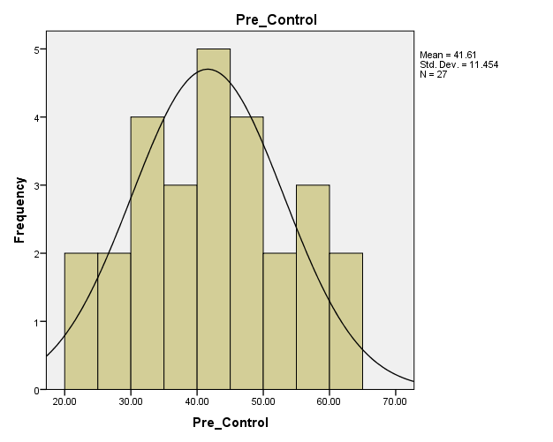

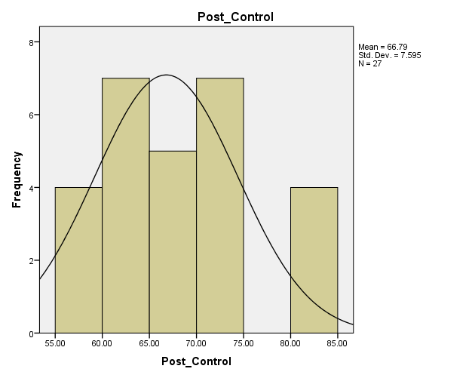

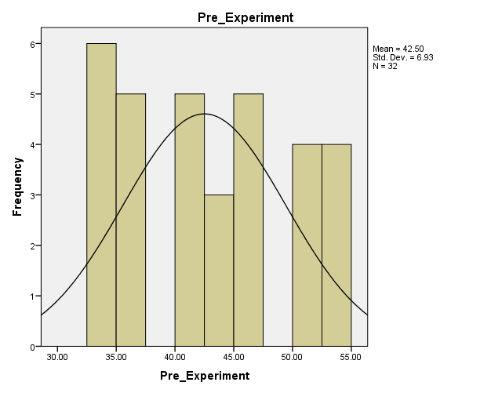

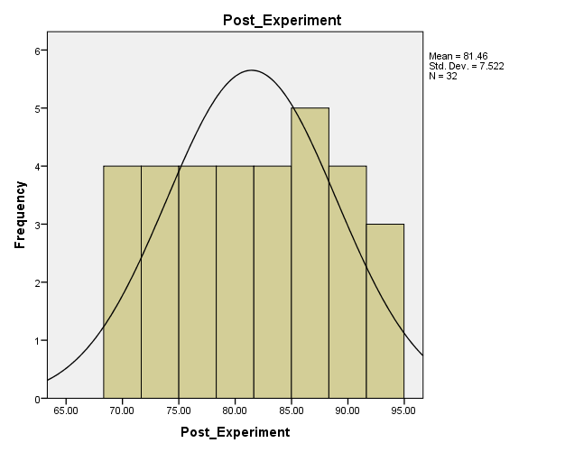

T-TEST PAIRS=Pre_Control Pre_Experiment WITH Post_Control Post_Experiment (PAIRED)
/CRITERIA=CI(.9500)
/MISSING=ANALYSIS.

T-Test

Notes
Output Created |  | 10-APR-2023 11:48:13
Comments
Input | Data | D:\Data Abah\Aktivitas 2023\Data Bu Kartini\Data Penelitian Ibu Kartini\Uji Normalitasi Pre dan Post.sav
Input | Active Dataset | DataSet1
Input | Filter | <none>
Input | Weight | <none>
Input | Split File | <none>
Input | N of Rows in Working Data File | 32
Missing Value Handling | Definition of Missing | User defined missing values are treated as missing.
Missing Value Handling | Cases Used | Statistics for each analysis are based on the cases with no missing or out-of-range data for any variable in the analysis.
Syntax |  | T-TEST PAIRS=Pre_Control Pre_Experiment WITH Post_Control Post_Experiment (PAIRED)  /CRITERIA=CI(.9500)  /MISSING=ANALYSIS.
Resources | Processor Time | 00:00:00.00
Resources | Elapsed Time | 00:00:00.01

Paired Samples Statistics
 |  | Mean | N | Std. Deviation | Std. Error Mean
Pair 1 | Pre_Control | 41.6111 | 27 | 11.45363 | 2.20425
Pair 1 | Post_Control | 66.7885 | 27 | 7.59476 | 1.46161
Pair 2 | Pre_Experiment | 42.4969 | 32 | 6.93046 | 1.22514
Pair 2 | Post_Experiment | 81.4581 | 32 | 7.52231 | 1.32977

Paired Samples Correlations
 |  | N | Correlation | Sig.
Pair 1 | Pre_Control & Post_Control | 27 | .449 | .019
Pair 2 | Pre_Experiment & Post_Experiment | 32 | .463 | .008

Paired Samples Test
 |  | Paired Differences |  |  |  |  | t | df | Sig. (2-tailed)
 |  | Mean | Std. Deviation | Std. Error Mean | 95% Confidence Interval of the Difference |  | t | df | Sig. (2-tailed)
 |  |  |  |  | Lower | Upper | t | df | Sig. (2-tailed)
Pair 1 | Pre_Control - Post_Control | -25.17741 | 10.52008 | 2.02459 | -29.33901 | -21.01580 | -12.436 | 26 | .000
Pair 2 | Pre_Experiment - Post_Experiment | -38.96125 | 7.50782 | 1.32721 | -41.66811 | -36.25439 | -29.356 | 31 | .000

NPAR TESTS
/K-S(NORMAL)=Pre_Control Post_Control Pre_Experiment Post_Experiment
/MISSING ANALYSIS.

NPar Tests

Notes
Output Created |  | 10-APR-2023 11:50:34
Comments
Input | Data | D:\Data Abah\Aktivitas 2023\Data Bu Kartini\Data Penelitian Ibu Kartini\Uji Normalitasi Pre dan Post.sav
Input | Active Dataset | DataSet1
Input | Filter | <none>
Input | Weight | <none>
Input | Split File | <none>
Input | N of Rows in Working Data File | 32
Missing Value Handling | Definition of Missing | User-defined missing values are treated as missing.
Missing Value Handling | Cases Used | Statistics for each test are based on all cases with valid data for the variable(s) used in that test.
Syntax |  | NPAR TESTS  /K-S(NORMAL)=Pre_Control Post_Control Pre_Experiment Post_Experiment  /MISSING ANALYSIS.
Resources | Processor Time | 00:00:00.00
Resources | Elapsed Time | 00:00:00.00
Resources | Number of Cases Allowedª | 112347
a. Based on availability of workspace memory.

One-Sample Kolmogorov-Smirnov Test
 |  | Pre_Control | Post_Control | Pre_Experiment | Post_Experiment
N |  | 27 | 27 | 32 | 32
Normal Parameters^{a,b} | Mean | 41.6111 | 66.7885 | 42.4969 | 81.4581
Normal Parameters^{a,b} | Std. Deviation | 11.45363 | 7.59476 | 6.93046 | 7.52231
Most Extreme Differences | Absolute | .106 | .148 | .142 | .131
Most Extreme Differences | Positive | .104 | .148 | .142 | .113
Most Extreme Differences | Negative | -.106 | -.107 | -.134 | -.131
Test Statistic |  | .106 | .148 | .142 | .131
Asymp. Sig. (2-tailed) |  | .200^{c,d} | .136^{c} | .098^{c} | .177^{c}
a. Test distribution is Normal.
b. Calculated from data.
c. Lilliefors Significance Correction.
d. This is a lower bound of the true significance.

Test of Homogeneity of Variances
Computational_Thinking_Skill
Levene Statistic | df1 | df2 | Sig.
,134 | 1 | 57 | ,716

ANOVA
Computational_Thinking_Skill
 | Sum of Squares | df | Mean Square | F | Sig.
Between Groups | 3151,365 | 1 | 3151,365 | 55,205 | ,000
Within Groups | 3253,832 | 57 | 57,085
Total | 6405,197 | 58

Tests of Between-Subjects Effects
Dependent Variable: Posttest
Source | Type III Sum of Squares | df | Mean Square | F | Sig. | Partial Eta Squared
Corrected Model | 3786,708ª | 2 | 1893,354 | 40,492 | ,000 | ,591
Intercept | 9202,421 | 1 | 9202,421 | 196,807 | ,000 | ,778
Pretest | 635,344 | 1 | 635,344 | 13,588 | ,001 | ,195
Kelas | 3008,760 | 1 | 3008,760 | 64,347 | ,000 | ,535
Error | 2618,488 | 56 | 46,759
Total | 336026,536 | 59
Corrected Total | 6405,197 | 58
a. R Squared = ,591 (Adjusted R Squared = ,577)

R Squred=0,577 terkategori sedang

