July 16th, 2018

Dear
Dra Beatriz Amante García
Universitat Politècnica de Catalunya, UPC. BARCELONA TECH,
Spain

Thank you and referees for your suggestible decision and referees’ helpful comments on our manuscript entitled “Engaging Scientific Literacy: Design of Heat and Temperature Experiments in High School". We have revised the manuscript upon careful consideration of the referees’ comments. Therefore, the title was slightly altered to “Heat and Temperature Experiment Designs to support Students’ Conception on Nature of Science”. The red color indicates our new revision. The green color is the new English grammar and spelling revision, meanwhile, the red color is the new revision of our manuscript. The revised manuscript and the detail responses to the referees are enclosed. Thank you very much.

We look forward to hearing from you at your earliest convenience.
Thank you,

Sincerely yours

Corresponding author:

Eka Cahya Prima, Ph.D.

Physics Education and Technology
Lecturer & Researcher

International Program on Science Education
Faculty of Mathematics and Science Education
UNIVERSITAS PENDIDIKAN INDONESIA
http://ipse.upi.edu

Mailing Address
Room S-201, FPMIPA A
Jl. Dr. Setiabudi No. 229 Bandung 40154 Indonesia
Telp/Fax +62 22 2013163

Mobile : +62-85793245289
Email : ekacahyaprima@upi.edu
Website : http://ekacahyaprima.staf.upi.edu/

Referees’ comments:

Referees’ #1 comments

- The main question, how can concepts about heat and temperature and their differences be acquired by students, is appropriate and merits study, and the practical works are a good way to help to obtain scientific literacy. However, the text falls short of what is expected. It does not show what the title intends. It describes some experiments to be performed by teacher and students in order to gain scientific literacy, but neither the description is complete or detailed enough they can be easily repeated without problems, nor the accompanying reasoning and methodology are shown and discussed in order to reply the educational path, besides what is assumed to be known by teachers, nor a proof of benefits is given (time to acquire competences, mean qualifications obtained by students...). A major revision is suggested, i.e., rewriting most of the article, in order to show lessons for other teachers and researchers in the educational field.

- For instance, the direct observation of the thermal expansion of a liquid (alcohol in fig. 3 right) would suggest “Why not use a parabolic thermal expansion law?” An “easy of use” argument should follow to justify a linear approximation, or an alternative could be to try to find why it appears as it does. Also, in the thermal expansion of a solid rod, the length is not indicated. If it is steel, with near 0.2 m length, expected expansion for a 40ºC temperature increase would be in the tenths of a millimeter, and with an ordinary digital ‘vernier’ caliper, it would be uncertain to try to obtain more than 3 digits for the coefficient of thermal expansion. The egg cracking device experiment is not well described. The use of the watt meter should be clarified, as the measure could be an indication of (specific + latent) heat capacity effect, or of the effect of thermal insulation. Finally, conclusions should be stated following the experience with the proposed experiments.

- The main question, how can concepts about heat and temperature and their differences be acquired by students, is appropriate and merits study, and the practical works are a good way to help to obtain scientific literacy. However, the text in the actual form must be improved before being published

Referees’ #2 comments

- This work presents a series of eight experiences of construction of scientific knowledge in an Indonesian high school with the purpose of developing a scientific culture in their pupils. The investigation topics are heat and temperature, which the students should distinguish and correctly apply in the resolution of daily problems. The conclusions are appropriate at the work presented.

- The work is interesting by the number of practices carried out and by being made by high schools students. But it doesn’t contribute new ideas or develops aspects of the evaluation of this improvement with respect to other methods of learning.

- The structure of the article is appropriate. The number of figures and diagrams is correct. However, some of the photographs presented haven’t adequate clarity or enough size, (Fig. 2, 3, 5 and 6). The compression of the above is not self-evident and a clearer explanation of some figures would require.

- The article is clear, readable and easily understood. The work is based on updated sources of bibliographic references. Perhaps, as a negative aspect, the expression "scientific literacy" are in excess used. Rewrite the Introduction text with alternative expressions with the same meaning or to allude to the concept of indirectly is recommended as far as possible.

- Even I am not a native English speaker, a full revision of English grammar and spelling is recommended. In the article, line 259, 262, 267 and 296, it appears the expression "egg-cracking machine", but the equipment described corresponds to an "egg incubator". Similarly, in 270, 284 lines, is expressed as "effect of blanket toward heat received and given" to the "effect of thermal insulation" which is more correct from a thermodynamic point of view.

RESPONSE TO REFEREE #1’S COMMENTS:

Referee’s Comments 1

The main question, how can concepts about heat and temperature and their differences be acquired by students, is appropriate and merits study, and the practical works are a good way to help to obtain scientific literacy. However, the text falls short of what is expected. It does not show what the title intends. It describes some experiments to be performed by teacher and students in order to gain scientific literacy, but neither the description is complete or detailed enough they can be easily repeated without problems, nor the accompanying reasoning and methodology are shown and discussed in order to reply the educational path, besides what is assumed to be known by teachers, nor a proof of benefits is given (time to acquire competences, mean qualifications obtained by students...). A major revision is suggested, i.e., rewriting most of the article, in order to show lessons for other teachers and researchers in the educational field.

Response to Referee’s Comments 1

Thank referee for giving the helpful suggestion. The comments are accepted. After carefully reviewing the whole of our article, we now have improved the overall content based on all your suggestions.

“How can concepts about heat and temperature and their differences be acquired by students, is appropriate and merits study, and the practical works are a good way to help to obtain scientific literacy. However, the text falls short of what is expected. It does not show what the title intends.”

How the concepts about heat and temperature and their differences, which are important to be acquired by students have been described in the Table 2 Line 154-155. We have discussed the importance of this experiment by describing the student’s competence acquired, assumptions, nature of science objectives, details of the experiment including materials used, experiment procedures, and the related problems in the daily life.

“It describes some experiments to be performed by teacher and students in order to gain scientific literacy, but neither the description is complete or detailed enough they can be easily repeated without problems, nor the accompanying reasoning and methodology are shown and discussed in order to reply the educational path, besides what is assumed to be known by teachers, nor a proof of benefits is given (time to acquire competences, mean qualifications obtained by students...). A major revision is suggested, i.e., rewriting most of the article, in order to show lessons for other teachers and researchers in the educational field.”

In this case, we have explained the complete details of experiments including the problems provided, assumption, and reasonable methods at lines 135 – 242.
No | Experiments | Student’s Competences | Assumptions | NOS Objectives | Details | Related Daily Problems | Allocated Time
1 | Demonstration activity to construct the concept of thermal expansion and temperature | - Identify a problem of physical means of thermal expansion  - Describe nature phenomena | - Students might not consider that the process of thermal expansion is reversible and it requires the heat.  - Students might think that his hand can be used to measure the temperature | Science is an attempt to explain natural phenomena | Type: Demonstration to construct science knowledge  Materials used: balloon, digital thermometer, thermometer, set of the burner, a beaker glass, Erlenmeyer flask, digital thermometer  Procedures  A. balloon is being heated  1. Close the Erlenmeyer flask by a balloon  2. Put the Erlenmeyer in a water-filled beaker glass  3. Put the beaker glass on the set of burner  4. Put the sensor of a digital thermometer in the beaker glass  5. Heat the beaker glass and observe the expansion of the balloon and the digital thermometer  B. thermometer is held by a hand  1. Hold the bottom edge of the thermometer  2. Observe the temperature on the thermometer display  3. Hang the thermometer and observe the thermometer display  C. a balloon is being blown  1. Provide the balloon, and blow it  2. Check the balloon temperature before blowing.  2. Observe the size of the blown balloon  3. Check the balloon temperature now. | - Why is a high-voltage power line installed rather loose?  - The engineer must pay attention to a gap between two bridges.  - A gap between glass and frame in the window. | 30 mins
2 | Experiment design to construct the concept of linear thermal expansion as the working principle of the thermometer | - Design experimental procedures to test the prediction of the nature of the thermal expansion | - Materials used in thermometer behave a linear thermal expansion  - Students might think that every liquid can be used as a material for the thermometer  - The increase of temperature in alcohol inside the test tube is the same as the increase of temperature in water detected by a digital thermometer | Scientists are creative | Type: Project to construct science knowledge  Materials used: Alcohol, coloring agent, test tube, rubber stopper, set of the burner, digital thermometer, glass straws  Procedures  - Fill the test tube by the colored alcohol  - Close the test tube by the glass straw-equipped rubber stopper.  - Put the test tube inside a water-filled beaker glass.  - Put a beaker glass on the set of burner  - Check the length expansion as the increase of the temperature.  - Compare the liquid expansion to the expansion of the alcohol inside thermometer. | - Why is water not be used as a material for the thermometer?  - How does the island relate to the special characteristics of water expansion? | 30 mins
3 | The effect of alcohol concentration towards linear thermal expansion | - Investigate new materials for the scientific improvement | - Alcohol is fully soluble in water  - The thermal expansion coefficient of water is the non-proportional response of temperature change. | New knowledge must be reported clearly and openly | Type: Project to solve the problem  Materials used: Alcohol, coloring agent, test tube, rubber stopper, set of the burner, digital thermometer, glass straws  Procedures  - The stages follow the second experiment.  - The materials used are elaborated by changing the concentration of alcohol: water of 90%, 70%, and 30% (v/v).  - Volume thermal coefficients of the mixture are investigated.  - Make a decision about what will happen if the alcohol as a thermometer material is changed by the mixture. | - Why is syrup or carbonated mixture not fully filled in the bottle? How does it happen if we put it under sunlight?  - How to put the scale and calibrate a thermometer? | 60 mins
4 | Equipment design to exercise problem-solving laboratory activities on making a thermometer | - Understanding the nature and importance of technology and the relationship between technology and science. | - The potential difference of the LM35 sensor behaves the proportional response to the temperature change.  - Students understand the electrical circuit of temperature sensor installation before running the experiment.  - The thermometer liquid materials behave the proportional response to the temperature change. | Science and technology impact each other | Type: Project to solve the problem  Materials used: Scaled thermometer, Bar thermometer, ruler, stand, Arduino Uno, Hook up wires, protoboard, potentiometer 10 kΩ, LM35 temperature sensor, 16x2 LCD Display, Printer USB, Computer  Procedures  Making analog thermometer  - the bar and the scaled thermometers are installed in parallel  - A ruler is required to set the level of material expansion at least on two conditions: at a freezing and a boiling points of water in 1 atmospheric pressure.  - A transparent tape can be attached on the bar thermometer so that the scale can be indicated.  Making digital thermometer  The details of the experimental procedure are described below the Table 2. | - The Celcius and Fahrenheit thermometers measure the same environment temperature. It shows the different values. Do you think that the degree of molecular vibration is different?  - When you are fever, how do you use the digital thermometer to measure your body temperature? | 90 mins
5 | Experiment design to construct the concept of the linear temperature expansion coefficient of some metals | - Conduct scientific experiment on thermal expansion  - Collect meaningful data, organize, and analyze data accurately and precisely | - The solid materials behave the proportional response to the temperature change. | Science is an attempt to explain natural phenomena  Scientists are creative | Type: Experiment to construct science knowledge  Materials used: Musschenbroek apparatus, video recorder, digital vernier caliper, electric heater, thermocouple type K, thermometer  Procedures  - Put the copper, zinc, brass, steel, and stainless steel on the Musschenbroek apparatus.  - The metal rod edge is firmly contacted to the depth measuring blade of digital vernier caliper.  - Set the display of length as zero for digital vernier caliper.  - The digital thermocouple is also equipped with a rod surface.  - Record the initial temperature of metals.  - To supply the uniform conduction, the electric heater is contacted on another edge of the metal rod.  - Plug in the electric heater.  - The temperature change and rod expansion are recorded by the video recorder. | - How is the railroad constructed to prevent the thermal bending?  - How does the iron not over overheat? | 60 mins
6 | Experiment designs of a bimetal strip model | - Do the action to obtain valid evidence. | - The bimetal strip is bent only due to the thermal coefficient difference. | Scientists are creative | Type: Project to solve the problem  Materials used: Paper, aluminum sheet, electric heater, glue  Procedures  - Cut the paper and aluminum sheet with the size of 5.0 x 0.75 cm.  - Glue one side of paper and aluminum sheet to be attached to each other.  - Let the materials dye for 5 minute  - Turn on the electric heater  - Put the handmade bimetal on the surface of the electric heater | - How is the bimetal applied to the thermostat and thermometer?  - How does the bimetal bend its shape? | 15 mins
7 | thermostat-equipped egg incubator | - Demonstrate an understanding of scientific concepts in different situations. | - The thermostat has a great sensitivity to response the environment temperature change.  - The temperature detected by the thermocouple sensor represents the uniformly distributed air temperature.  - The thermostat keeps the air temperature constant during the incubation. | Scientific ideas affect social culture | Type: Project to solve the problem  Materials used: Thermocouple, WillhiTM thermostat, digital thermometer, wire, lamp, lamp holder, switch, plastic box,  Procedures  - Install the probe of the K-type thermocouple to the NTC port 7 and 8 of the thermostat.  - Connect the power wire to power port 3 and 4 of the thermostat.  - Connect the lamp wire to the load port 1 and 2 of the thermostat  - Open this link for detail schematic circuit https://www.youtube.com/watch?v=BpwAk69Aoag  - Press RST key to switch on and off, press the RST key on the power-off state once to turn on, on the power-on state, press the RST key for three seconds and hold on, then it will be off.  - Press the SET key once to enter the temperature control setting, press ▲ or ▼ button to adjust, press ▲ or ▼ button for three seconds and hold to enter the fast adjusting mode, press the SET key again to exit setting mode | - How to incubate the eggs effectively so that the egg hatches on time?  - How the Inflatable incubator help save premature babies? | 90 mins
8 | Experiment design for investigating the effect of thermal insulation | - Conduct scientific experiment on thermal insulation | - The greater the heat received by the system, the little the heat lost to the environment.  - The efficiency of electric heater machine is constant during the experiment. | Science is an attempt to explain natural phenomena | Type: Project to solve the problem  Materials used: Electric heater, WANF Watt meter, water, insulation materials including styrofoam, sawdust, dacron, cartoon, calorimeter, and digital thermometer  Procedures  - Measure the diameter of the container  - Prepare the blanket of the thermal insulator by making two cylinders with 3 cm diameter different.  - Prepare the similar blanket as the container cover.  - Put the container inside the insulation blanket.  - Insert the insulation materials between two cylinder cartoon.  - Fill the 500 ml water into the container  - Install the digital thermometer in the container.  - Cover the container with the blanket cover.  - Put it on the water heater.  - Plug in the watt meter into the electric socket.  - Plug in the heater-plug into the watt meter.  - Turn on the watt meter  - Record the initial temperature of water in the container.  - Set the watt meter to view the energy used by an electric heater.  - Monitor the energy used by an electric heater to be set as heat given. At the same time, monitor the increase of water temperature inside the container to be processed as heat received. | - How is the best way to design the vacuum flask?  - How to keep the temperature of hot coffee in a glass? | 90 mins
Table 2. The complete experiment designs on heat and temperature supporting the student’s nature of science

4th Experiment: Building the digital thermometer using an Arduino-based LM35 Temperature sensor
Arduino is an open source and single microprocessor single-board designed to ease the users constructing the electronics. The hardware has Atmel AVR processor and unique software based on C++ programming language. Arduino Uni board is the common microcontroller used by beginners. The last version of the Arduino Uno R3 (Revision 3) applies ATMEGA328 as a microcontroller. It has 14 digital I/O pins and 6 analog input pins. Figure 2 shows the part of Arduino R3.
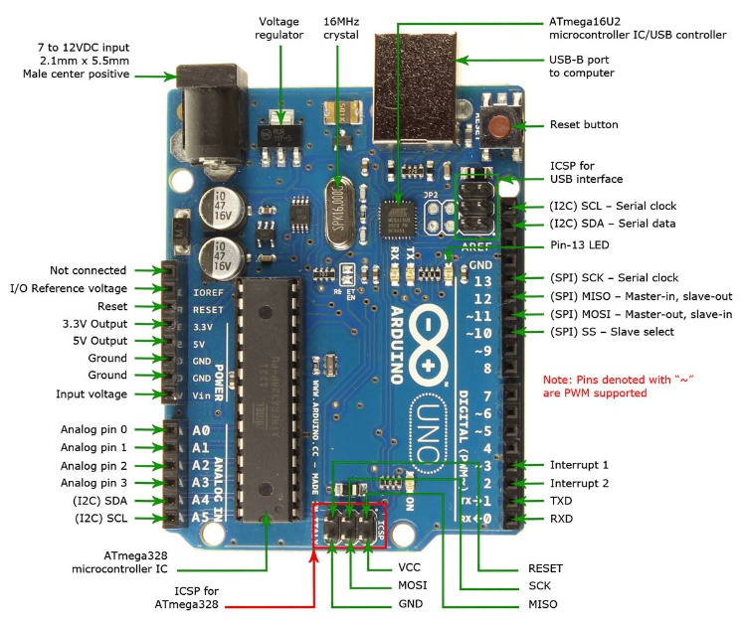
Figure 2. Part of Arduino Uno R3
To construct the project, the analog LM35 temperature sensor is used. This sensor is able to measure the temperature range from -55ºC to 150ºC, with the temperature resolution of 0.5ºC, accuracy ±1.5ºC. The change of 10mV potential difference will alter the linear temperature by 1ºC. Figure 3 shows the graph of current and potential difference due to the temperature change.
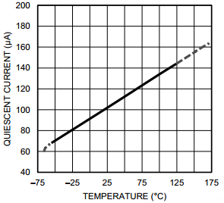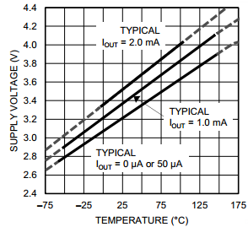
Figure 3. The current and potential difference change due to the temperature difference.
The solderless protoboard is used to arrange the electrical circuit. The electronic devices are pinned into the protoboard holes. Student’s understanding of the protoboard pattern is required to construct the right electrical circuit. Figure 4 shows the pattern of protoboard in rows and columns.
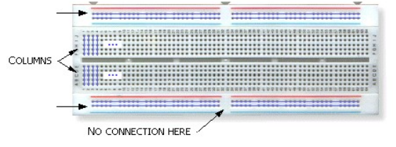
Figure 4. The pattern of protoboard in rows and columns.
In this project, students can build a temperature sensor circuit based on an LM35 sensor and integrate it to an LCD. Therefore, the temperature can be read on the LCD. They have to connect the circuit to mimics a more like electronic product where students see it on the market. To construct this circuit, they need 3 main components. This project will use an LM35 temperature sensor. An HD44780 16x2 LCD display is needed to read the temperature. Moreover, the Arduino Uno as a microcontroller is required to interpret the readout of LM35 sensor IC and then display it on the LCD. Of course, students need to hook up wires to wire all the connections.
The circuit which we will build to interface a temperature sensor to an LCD for LCD readout is shown in Figure 5.
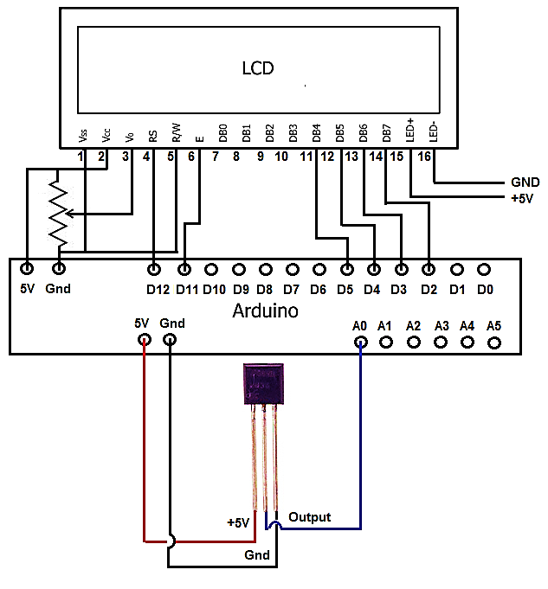
Figure 5. The schematic circuit to construct the hands-on digital thermometer.
These stages discuss how to connect the LCD to Arduino. (a) The LCD pin GND must be connected to the Arduino pin GND. (b) The LCD pin +5V must be connected to the Arduino pin 5V. (c) The LCD pin Contrast is not connected to the Arduino pin. (d) The LCD pin RS (Register Select Pin) must be connected to the Arduino pin 12. (e) The LCD pin R/W (Read/Write Pin) must be connected to the Arduino pin GND. (f) The LCD pin E (Clock Enable Pin) must be connected to the Arduino pin 11. (g) The LCD pins D0-D4 are not connected to the Arduino pin. (h) The LCD pin D4 must be connected to the Arduino pin 5. (i) The LCD pin D5 must be connected to the Arduino pin 4. (j) The LCD pin D6 must be connected to the Arduino pin 3. (k) The LCD pin D7 must be connected to the Arduino pin 2. (l) The LCD pin Anode (for backlight) must be connected to the Arduino pin 5V. (m) The LCD pin Cathode (for backlight) must be connected to the Arduino pin GND.
These stages discuss how to connect the LM35 sensor to Arduino. Follow these stages to construct the successful project. (a) The LM35 pin +5V must be connected to the Arduino pin 5V. (b) The LM35 pin Output must be connected to the Arduino pin A0. (c) The LM35 pin GND must be connected to the Arduino pin GND.
The code is required to interpret the LM35 sensor signal. The first line of code includes the LiquidCrystal library. With this library, we can utilize functions (such as lcd.print) that make coding this project much easier. The fifth block of code is our actual loop for our circuit. In this block, we read the analog voltage from the temperature sensor IC from the output pin. We convert this voltage into temperature Fahrenheit. We then print out this temperature to the lcd using the lcd.print function. We then take a 5-second delay. This way, the temperature IC reads and updates the temperature every 5 seconds.
Code
#include <LiquidCrystal.h>
int outputpin= 0;
const int numRows= 4;
const int numCols= 20;
//initialize the library with the numbers of the interface pins
LiquidCrystal lcd(12, 11, 5, 4, 3, 2);
void setup()
{
Serial.begin(9600);
lcd.begin(numCols, numRows);
lcd.print("Temperature: ");
}
//main loop
void loop()
{
int rawvoltage= analogRead(outputpin);
float millivolts= (rawvoltage/1024.0) * 5000;
float fahrenheit= millivolts/10;
lcd.print(fahrenheit);
lcd.print(" °F");
delay(5000);
}
Referee’s Comments 2

For instance, the direct observation of the thermal expansion of a liquid (alcohol in fig. 3 right) would suggest “Why not use a parabolic thermal expansion law?” An “easy of use” argument should follow to justify a linear approximation, or an alternative could be to try to find why it appears as it does. Also, in the thermal expansion of a solid rod, the length is not indicated. If it is steel, with near 0.2 m length, expected expansion for a 40ºC temperature increase would be in the tenths of a millimeter, and with an ordinary digital ‘vernier’ caliper, it would be uncertain to try to obtain more than 3 digits for the coefficient of thermal expansion. The egg cracking device experiment is not well described. The use of the watt meter should be clarified, as the measure could be an indication of (specific + latent) heat capacity effect, or of the effect of thermal insulation. Finally, conclusions should be stated following the experience with the proposed experiments.

Response to Referee’s Comments 2

The comments are accepted, we have revised the explanation based on your suggestion.

“For instance, the direct observation of the thermal expansion of a liquid (alcohol in fig. 3 right) would suggest “Why not use a parabolic thermal expansion law?” An “easy of use” argument should follow to justify a linear approximation, or an alternative could be to try to find why it appears as it does.”

In our revision, to ease data collection and show more accurate data, the measurement is performed using a digital thermometer while the length expansion of alcohol is recorded using a video recorder. This strategy is very helpful to investigate temperature change during volume expansion. The graph is also taken from data of volume expansion in liquids. It can be concluded that this experiment can facilitate students to test the prediction of the nature of thermal expansion. Students propose the hypotheses that the graph is predicted as the linear expansion. This property is important to set the good quality of thermometer. The assumptions are addressed to this result, the increase of temperature of alcohol inside the test tube should be the same as the increase of temperature in water detected by a digital thermometer. If the fact does not follow the assumption, the result tends to show the small error. As a result, the alcohol linear expansion tends to show the proportional function to the 96.84% linear expansion with the function of ΔL=0.2326 ΔL - 0.37102 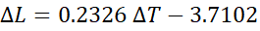and 3.16% error. The error can be found due to the difficulties of placing the digital thermometer in the water. It is previously assumed that the temperature indicated by the thermometer is the same as the temperature inside the alcohol-cylinder thermometer. Furthermore, the effect of heat received by the glass is also neglected in this investigation. The hand-made thermometer calibration can be conducted after obtaining this data. Students are able to make lines in this small cylinder to indicate certain temperatures. Finally, the hand-made thermometer can be used in another case for exercising the student’s creativity as a goal of the nature of science. Students understand the basic principle of the thermometer, plan the thermal expansion experiment, and make a product as required in a conception on the nature of science.

“in the thermal expansion of a solid rod, the length is not indicated. If it is steel, with near 0.2 m length, expected expansion for a 40ºC temperature increase would be in the tenths of a millimeter, and with an ordinary digital ‘vernier’ caliper, it would be uncertain to try to obtain more than 3 digits for the coefficient of thermal expansion.”

In our revision, To use this equipment, the metal rod (30 cm length, 6.5 mm diameter) is placed on the Musschenbroek apparatus, students use materials from copper, zinc, brass, steel, and stainless steel for this experiment...
No | Materials | Linear Temperature Expansion Coefficient  α_{measured} (K⁻¹) | Reference  α_{standard} (K⁻¹) | Percentage Error (%)
1 | Copper | 1.74 × 10⁻⁵ | 1.70 × 10⁻⁵ | 2.29
2 | Zinc | 2.94 × 10⁻⁵ | 3.00 × 10⁻⁵ | 1.93
3 | Brass | 1.96 × 10⁻⁵ | 1.90 × 10⁻⁵ | 3.05
4 | Steel | 1.11 × 10⁻⁵ | 1.18 × 10⁻⁵ | 5.93
5 | Stainless Steel | 1.77 × 10⁻⁵ | 1.73 × 10⁻⁵ | 2.08
Table 2. Experiment result of linear temperature expansion coefficient based on equipment design in Figure 6

“The egg cracking device experiment is not well described. The use of the watt meter should be clarified, as the measure could be an indication of (specific + latent) heat capacity effect, or of the effect of thermal insulation. Finally, conclusions should be stated following the experience with the proposed experiments.”

In our revision, For the industrial purposes, the utilization of bimetal is also applied to the egg incubator electronically. In a thermostat, there is a bimetal that actually moves as the temperature changes and this movement causes the electrical connection to open or close. As they expand and contract differently, they move closer together or farther apart. This is what causes the electrical connection to open or close. In this work, a digital thermostat will include a thermometer as part of the device so the students can set the incubator thermostat to the desired set-point and then just walk away. A room (40 x 30 x 30 cm) made of plastics can be set to construct the egg incubator. In this design, the environmental temperatures can be maintained and controlled by an electrical thermostat. Heat is given by a lamp placed in the container while eggs are placed in the same container. The thermostat will monitor heat produced by the lamp, and the lamp will turn on and turn off based on the temperature set by ourselves. Although the results should be further optimized, students can really apply the concept of bimetal in manufacturing egg incubator.

The experiment detail of egg incubator was also described in Table 2 Point (7) as seen below.

No | Experiments | Student’s Competences | Assumptions | NOS Objectives | Details | Related Daily Problems | Allocated Time
7 | thermostat-equipped egg incubator | - Demonstrate an understanding of scientific concepts in different situations. | - The thermostat has a great sensitivity to response the environment temperature change.  - The temperature detected by the thermocouple sensor represents the uniformly distributed air temperature.  - The thermostat keeps the air temperature constant during the incubation. | Scientific ideas affect social culture | Type: Project to solve the problem  Materials used: Thermocouple, WillhiTM thermostat, digital thermometer, wire, lamp, lamp holder, switch, plastic box,  Procedures  - Install the probe of the K-type thermocouple to the NTC port 7 and 8 of the thermostat.  - Connect the power wire to power port 3 and 4 of the thermostat.  - Connect the lamp wire to the load port 1 and 2 of the thermostat  - Open this link for detail schematic circuit https://www.youtube.com/watch?v=BpwAk69Aoag  - Press RST key to switch on and off, press the RST key on the power-off state once to turn on, on the power-on state, press the RST key for three seconds and hold on, then it will be off.  - Press the SET key once to enter the temperature control setting, press ▲ or ▼ button to adjust, press ▲ or ▼ button for three seconds and hold to enter the fast adjusting mode, press the SET key again to exit setting mode | - How to incubate the eggs effectively so that the egg hatches on time?  - How the Inflatable incubator help save premature babies? | 90 mins

Referee’s Comments 3

The main question, how can concepts about heat and temperature and their differences be acquired by students, is appropriate and merits study, and the practical works are a good way to help to obtain scientific literacy. However, the text in the actual form must be improved before being published

Response to Referee’s Comments 3

In this case, we have explained the complete details of experiments including the problems provided, assumption, and reasonable methods at lines 135 – 242 as described previously.

RESPONSE TO REFEREE #2’S COMMENTS:

Referee’s Comments 1

This work presents a series of eight experiences of construction of scientific knowledge in an Indonesian high school with the purpose of developing a scientific culture in their pupils. The investigation topics are heat and temperature, which the students should distinguish and correctly apply in the resolution of daily problems. The conclusions are appropriate at the work presented.

Response to Referee’s Comments 1

Thank referee for giving the helpful suggestion.

Referee’s Comments 2

The work is interesting by the number of practices carried out and by being made by high schools students. But it doesn’t contribute new ideas or develops aspects of the evaluation of this improvement with respect to other methods of learning.

Response to Referee’s Comments 2

Thank referee for giving the helpful suggestion. After carefully review the whole of our article, we now have improved the overall content based on all your suggestions as seen in

Line 52-83

The nature of science refers to the science as a way of knowing, epistemology of science, or the beliefs and value inherent to the scientific knowledge development (Lederman, Lederman & Antink, 2013). A consensus view of the nature of science objectives is taken from the documents of eight international science standards (McComas, Clough & Almazroa, 1998). For instance, scientists are able to formulate and test their explanations of nature using observation, experiments, and theoretical and mathematical models. In areas where active research being pursued, it is normal for a scientist to differ from one another about the interpretation of the theory or evidence. Accordingly, the examination includes reviewing the experimental procedures, examining the evidence, identifying faulty reasoning, pointing out scientific interpretation, and suggesting alternative reasons for the same observations. McComas, Clough, and Almazroa (1998) also suggested that requiring that preservice teachers conduct more experience on laboratory research projects are often believed to be the solution to improve prospective science teachers’ understanding of the nature of science. Lederman, Abd‐El‐Khalick, Bell, and Schwartz (2002) found that (78%) explicitly stated the misconception that scientific theories become laws when it was proven through repeated testing. Interestingly, it was also believed that laws were proven true and theories were tentative, either because not enough data are available or because scientists are unable to design experiments or apparatus to test theories adequately. It is a challenge to a teacher to design good experiments and to set up apparatus correctly.
The teacher’s difficulty in showing a real natural phenomenon will affect to construct students’ knowledge. Teachers must guarantee that the scientific content is meaningful and important to students, not as lifeless abstractions (DeBoer, 2000). They should conduct this process using inquiry-based or constructivist teaching. Duschl (1987) states that teachers themselves need to have an adequate understanding of the nature of science. Therefore, the teachers conduct ‘real science’ investigations of their own design and use the results to generate inquiry-based lessons for the classroom (Lederman, Abd‐El‐Khalick, Bell & Schwartz, 2002). To improve the nature of science, PISA (2015) suggested that the teachers need to design well-structured laboratory activities that make actual scientific concepts and ideas. It will help students make the connections among the scientific ideas, hands-on activities, and real-life problems. Students should also be made aware that while conducting these activities, they are manipulating objects as well as ideas. However, presenting contextual problems in terms of the real situation is a challenge to a science teacher (Karim, Prima, Utari, Saepuzaman, and Nugaha, 2017). The reason, why a teacher feels difficult serving this equipment, is a lecturer weakness in providing the real scientific experiences to the prospective students (Özdem et al., 2010). The educational curricula must engage the student to be able to design good science experiments. In order to design the science experiments, we refer to the instructional model developed by Dick & Carey (Dick, 1996) as seen in Figure 1.

Line 112-133

In fact, it is found that students have a rather unsatisfactory understanding of heat and temperature (Shirish, Saurabhee, Madhura, Savita & Hemachandra, 2015). To overcome the problem, the previous works have reported the investigation of heat transfer for educational purposes. An open inquiry (OI)-based learning experience is presented to investigate the process of energy exchange by thermal radiation (Nicola, Claudio & Onofrio Rosario, 2014). The learning method allowed us to analyze the teachers’ feedback from a pedagogical point of view. Yeung Chung (2007) recommended the strategy to engage students in constructing concepts by giving the problems based on scientific demonstration. Shirish, Saurabhee, Madhura, Savita, and Hemachandra (2015) have designed a module of five activities to improve student’s understanding of thermal equilibrium. Moreover, Kevin (2000) implemented the experiment through discussion to acquire the necessary concepts in thermal physics. The key concepts consist of thermal equilibrium, the notion of flow of heat energy, and the ability to differentiate between heat and temperature. Williams, Nguyen, and Mangan (2017) present a case study of a teacher’s experience in implementing an inquiry approach using information technologies to support student inquiry learning on the temperature of the water during evaporating and time to evaporate. Rodríguez García, Astrain Ulibarrena, Martínez Echeverri, Aranguren Garacochea and Pérez Artieda (2013) built and validated a practical bench to study cooling and thermal generation. It has also been simulated thermoelectric refrigeration or generation. In this way, students can reach a new technology that is not normally seeing in their previous studies. We have previously reported heat transfer laboratory kit using temperature sensor-based ArduinoTM for educational purpose (Prima et al., 2017). In this work, we will propose two types of media based on heat and temperature experiment used to construct science knowledge and to serve problem-solving laboratory. The developed experiment designs refer to PISA 2015 frameworks. The context domains consist of the personal context showing the personal energy use and the scientific aspects, while the local context presents the development of new materials and equipment.

Referee’s Comments 3

The structure of the article is appropriate. The number of figures and diagrams is correct. However, some of the photographs presented haven’t adequate clarity or enough size, (Fig. 2, 3, 5 and 6). The compression of the above is not self-evident and a clearer explanation of some figures would require.

Response to Referee’s Comments 3

The comment is accepted, we have revised that figures in 300 dpi. The detail explanation of the experiment has been described in Table 2.

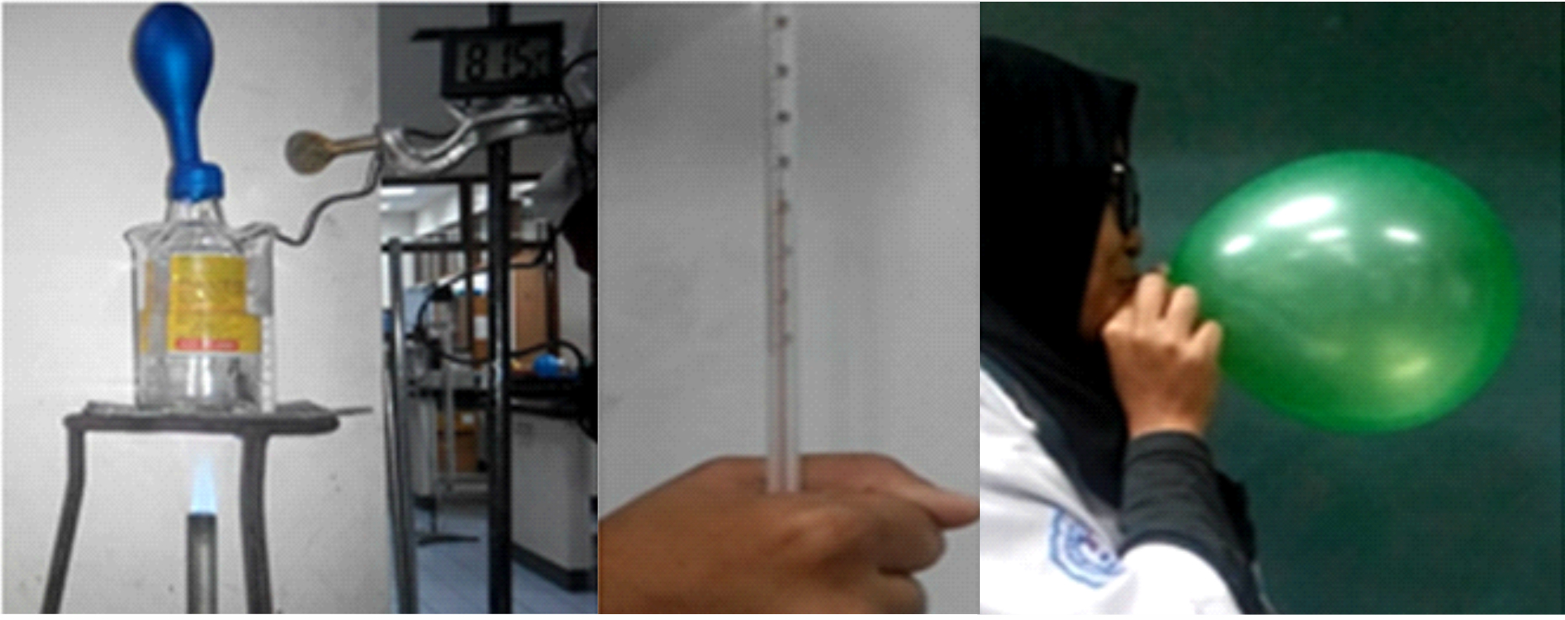
(a) (b) (c)
Figure 6. Demonstration activity to construct the concept of thermal expansion and temperature. (a) a balloon is being heated, (b) thermometer is held by a hand, (c) a balloon is being blown.

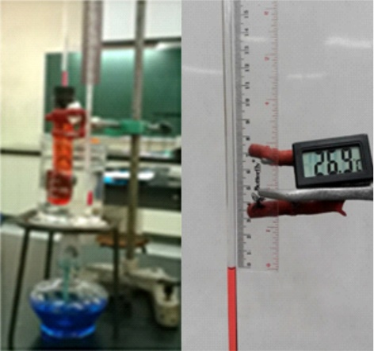
Figure 7. Second experiment design to construct the concept of linear thermal expansion as the working principle of the thermometer

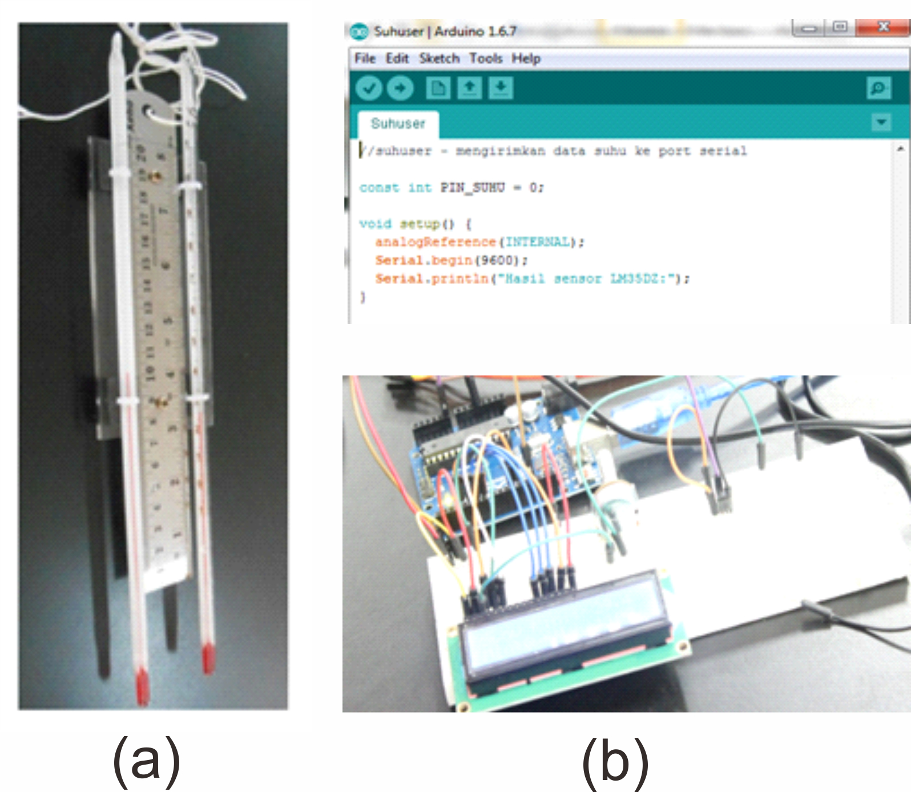
Figure 9. Fourth Equipment design to exercise problem-solving laboratory activities on making (a) an

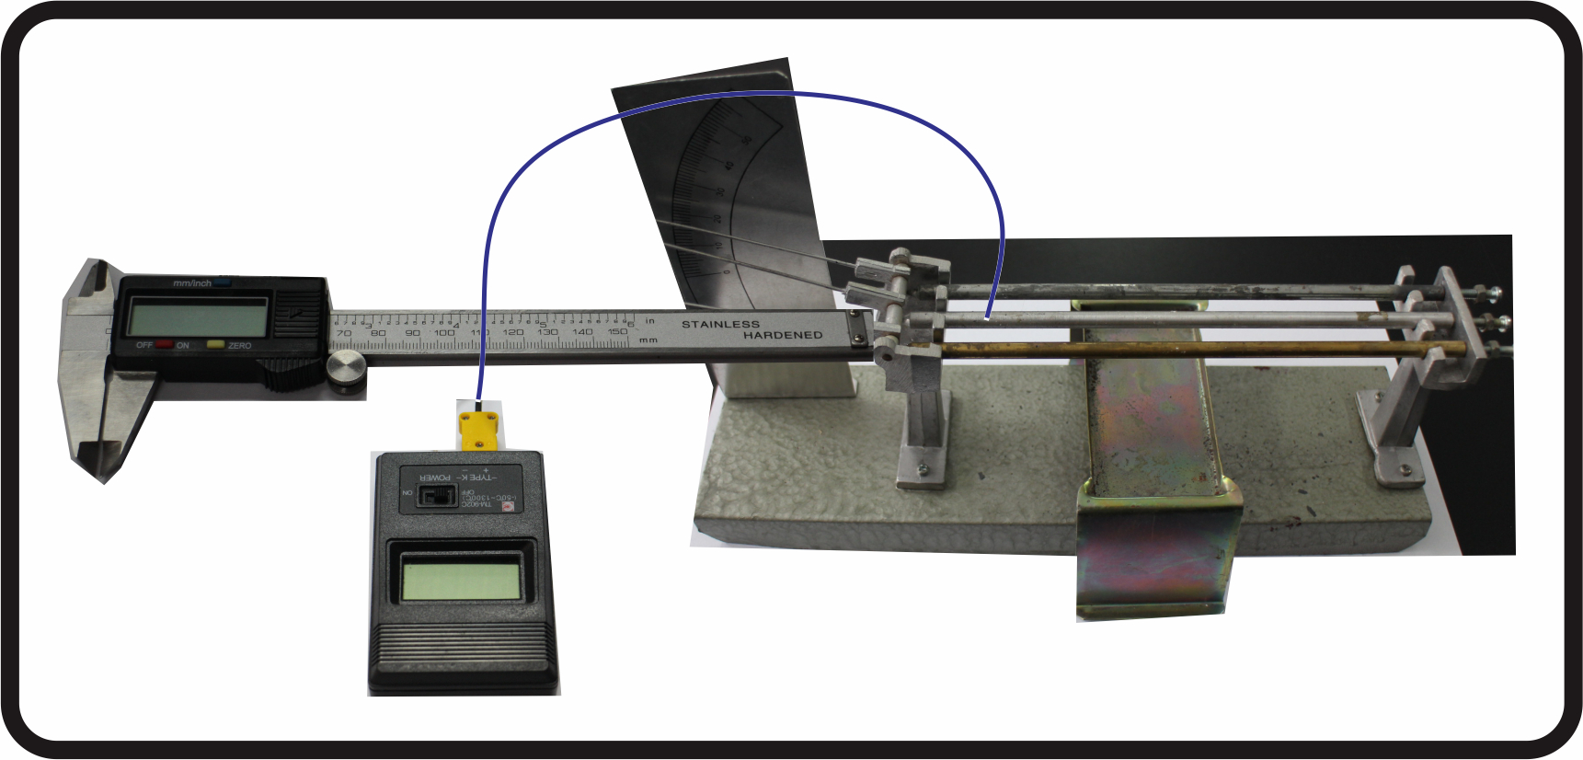
Figure 10. Fifth experiment design to construct the concept of the linear temperature expansion coefficient of some metals

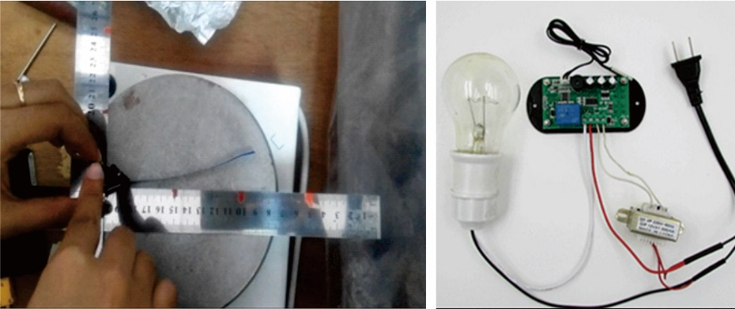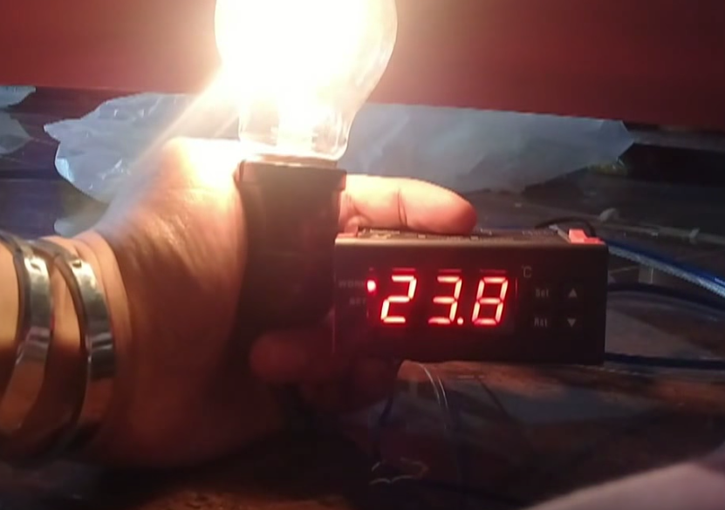
(b)
(a)

Figure 11. Experiment designs of (a) bimetal strip model and (b) thermostat-equipped egg incubator

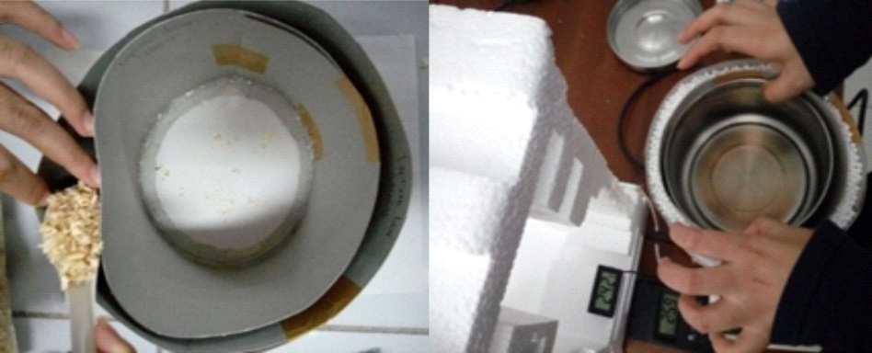
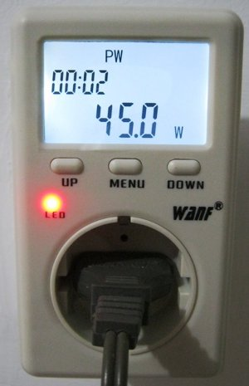
Figure 12. Experiment design for investigating the effect of thermal insulation

Referee’s Comments 4

The article is clear, readable and easily understood. The work is based on updated sources of bibliographic references. Perhaps, as a negative aspect, the expression "scientific literacy" are in excess used. Rewrite the Introduction text with alternative expressions with the same meaning or to allude to the concept of indirectly is recommended as far as possible.

Response to Referee’s Comments 4

The comment is accepted and very helpful. The excess used of “scientific literacy” has been reviewed and we prefer to use the nature of science as the foundation of this research. According to this suggestion, we now have revised the whole of introduction as seen in Lines 19-133.

The increase in the population growth rate may affect several problems. The lack of people understanding on scientific insight to make a good decision might cause the social problems and natural disasters such as an unemployment, a colonialist, a poverty, a flooding, a fire, and so on. As a citizen, we have to concern on how to solve these problems by improving the people-scientific mindset. Moreover, PISA (2015) study on scientific literacy showed that Indonesia was positioned at 62th out of 70 countries participating in the survey. The student’s understanding of scientific investigations has to be gained so that they are able to adapt to a modernization. Art (2003) viewed that the modernization of social life was closely related to the development of science and technology. This transformation cannot be realized so that the new generations are able to understand the new issues and to make a decision based on scientifically reasonable evidence. Therefore, a literate citizen should be able to evaluate the quality of scientific information on his participation in civic and cultural affairs, and economic productivity (Miller, 1983). To realize this condition, learning activities should not only focus on what students know about science, but also concern on how they use science to make a decision based on scientific information. Consequently, a good teacher must have an awareness of his duties as an educator. He must facilitate students finding several ways of developing their own potential because this is the child's right to obtain the best opportunity (Eisenkraft, 2010).
Science is a good particular way to understand the natural phenomena. Students should learn how to use their way of thinking to investigate the factual issues (DeBoer, 2000). Therefore, Dewey (1904) argued that the inquiry-based learning presented a real experience using scientific ways of building knowledge or solving problems. The student’s conception on ‘nature of science’ are required to be carried out because the terms relate to an epistemology of science, science as a way of knowing, or the values to the scientific knowledge development (Abd-El-Khalick & Lederman, 2000). Compared to other aspects of scientific literacy, an adequate understanding of the nature of science (NOS) plays the most important role in improving the scientific literacy (AAAS, 1990). The scientific literacy refers to the ability of the individual to read, comprehend, and express his opinion on scientific matters are required to become a scientifically literate person (Miller, 1983). National Research Council (1996) initiated scientific literacy including (a) concepts and processes for physics and biology, (b) inquiry scientific methods, (3) science application in daily life, and (4) social and environmental implications and technology development. Scientific literacy is nowadays a goal of science education (Wenning, 2006). By considering the large scope of scientific literacy, the assessing direct improvement of scientific literacy is quite complicated to be accomplished. PISA (2015) strongly recommend that the most important thing to be trained to the student is by implementing experiments and hands-on activities. This work can help students develop a conceptual understanding of scientific ideas and transferable skills, such as critical thinking. This investigation will construct students’ way of knowing as a critical aspect of the conception of the nature of science.
The nature of science refers to the science as a way of knowing, epistemology of science, or the beliefs and value inherent to the scientific knowledge development (Lederman, Lederman & Antink, 2013). A consensus view of the nature of science objectives is taken from the documents of eight international science standards (McComas, Clough & Almazroa, 1998). For instance, scientists are able to formulate and test their explanations of nature using observation, experiments, and theoretical and mathematical models. In areas where active research being pursued, it is normal for a scientist to differ from one another about the interpretation of the theory or evidence. Accordingly, the examination includes reviewing the experimental procedures, examining the evidence, identifying faulty reasoning, pointing out scientific interpretation, and suggesting alternative reasons for the same observations. McComas, Clough, and Almazroa (1998) also suggested that requiring that preservice teachers conduct more experience on laboratory research projects are often believed to be the solution to improve prospective science teachers’ understanding of the nature of science. Lederman, Abd‐El‐Khalick, Bell, and Schwartz (2002) found that (78%) explicitly stated the misconception that scientific theories become laws when it was proven through repeated testing. Interestingly, it was also believed that laws were proven true and theories were tentative, either because not enough data are available or because scientists are unable to design experiments or apparatus to test theories adequately. It is a challenge to a teacher to design good experiments and to set up apparatus correctly.
The teacher’s difficulty in showing a real natural phenomenon will affect to construct students’ knowledge. Teachers must guarantee that the scientific content is meaningful and important to students, not as lifeless abstractions (DeBoer, 2000). They should conduct this process using inquiry-based or constructivist teaching. Duschl (1987) states that teachers themselves need to have an adequate understanding of the nature of science. Therefore, the teachers conduct ‘real science’ investigations of their own design and use the results to generate inquiry-based lessons for the classroom (Lederman, Abd‐El‐Khalick, Bell & Schwartz, 2002). To improve the nature of science, PISA (2015) suggested that the teachers need to design well-structured laboratory activities that make actual scientific concepts and ideas. It will help students make the connections among the scientific ideas, hands-on activities, and real-life problems. Students should also be made aware that while conducting these activities, they are manipulating objects as well as ideas. However, presenting contextual problems in terms of the real situation is a challenge to a science teacher (Karim, Prima, Utari, Saepuzaman, and Nugaha, 2017). The reason, why a teacher feels difficult serving this equipment, is a lecturer weakness in providing the real scientific experiences to the prospective students (Özdem et al., 2010). The educational curricula must engage the student to be able to design good science experiments. In order to design the science experiments, we refer to the instructional model developed by Dick & Carey (Dick, 1996) as seen in Figure 1.
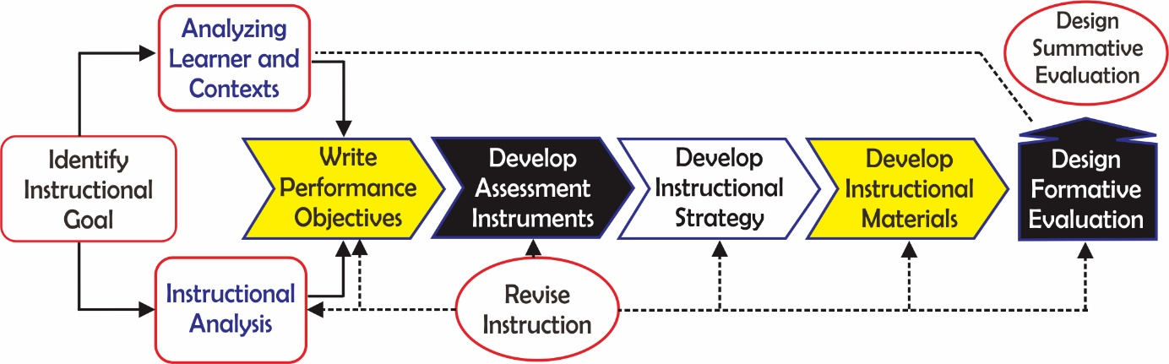
Figure 1. Model of instructional design by Dick & Carey (Dick, 1996)
During identifying learning achievements, the lesson not only refers to the competencies required by the curriculum but also considers the conception of the nature of science ( Organisation for Economic & PISA, 2013). The characteristics of learners should be recognized to provide wise ways of building their knowledge so that students are interested and not easily frustrated. They also behave with good attitudes and positive perceptions (Marzano, Pickering & McTighe, 1993). For example, a teacher firstly shows a contextual phenomenon related to the expected concept. He composes learning outcomes as a base for developing instrument and learning strategies. This learning strategy is a basis for developing learning media required for the learning process. Finally, both formative and summative tests are composed to evaluate students’ conception of the nature of science.
Heat and temperature concepts are interesting to be investigated by students because the phenomenon can be found in daily life. The concepts are also presented in the PISA 2015 Scientific Literacy Benchmark such as questions about global warming, starlight and lip gloss (PISA, 2015). Moreover, the increase of automation technology makes a farmer think the best solution to design the best condition for farming and harvesting. The researchers also seek the best strategy to overcome the negative impacts of global warming. The cases must be investigated scientifically in order to infer the concept and to propose the alternative solutions. Understanding the heat and temperature contributes to a more informed and intelligent experience with the natural world as expected in the Goals of the Science Teaching (Dethe Boer, 2000). To achieve this goal, students are guided to understand that heat consists of random motion and the vibrations of atoms, molecules, and ions. The higher the temperature, the greater the atomic or molecular motion. In nature, everything tends to become less organized and less orderly over time. Moreover, in all energy transfers, the overall effect is that the energy is spread out uniformly. For instance, the energy transfer comes from hotter to cooler objects by conduction, radiation, or convection and the warming of our surroundings when we burn fuels. Clough (2011) presented the contextual fact that beyond our homes, massive road networks now span our nation, and clean water and sanitation systems serve our cities and towns. Power plants and grids provide reliable electricity to heat and light our homes. It is suggested that this understanding will improve the student’s conception of the nature of science as a fundamental part of scientific literacy.
In fact, it is found that students have a rather unsatisfactory understanding of heat and temperature (Shirish, Saurabhee, Madhura, Savita & Hemachandra, 2015). To overcome the problem, the previous works have reported the investigation of heat transfer for educational purposes. An open inquiry (OI)-based learning experience is presented to investigate the process of energy exchange by thermal radiation (Nicola, Claudio & Onofrio Rosario, 2014). The learning method allowed us to analyze the teachers’ feedback from a pedagogical point of view. Yeung Chung (2007) recommended the strategy to engage students in constructing concepts by giving the problems based on scientific demonstration. Shirish, Saurabhee, Madhura, Savita, and Hemachandra (2015) have designed a module of five activities to improve student’s understanding of thermal equilibrium. Moreover, Kevin (2000) implemented the experiment through discussion to acquire the necessary concepts in thermal physics. The key concepts consist of thermal equilibrium, the notion of flow of heat energy, and the ability to differentiate between heat and temperature. Williams, Nguyen, and Mangan (2017) present a case study of a teacher’s experience in implementing an inquiry approach using information technologies to support student inquiry learning on the temperature of the water during evaporating and time to evaporate. Rodríguez García, Astrain Ulibarrena, Martínez Echeverri, Aranguren Garacochea and Pérez Artieda (2013) built and validated a practical bench to study cooling and thermal generation. It has also been simulated thermoelectric refrigeration or generation. In this way, students can reach a new technology that is not normally seeing in their previous studies. We have previously reported heat transfer laboratory kit using temperature sensor-based ArduinoTM for educational purpose (Prima et al., 2017). In this work, we will propose two types of media based on heat and temperature experiment used to construct science knowledge and to serve problem-solving laboratory. The developed experiment designs refer to PISA 2015 frameworks. The context domains consist of the personal context showing the personal energy use and the scientific aspects, while the local context presents the development of new materials and equipment.

Referee’s Comments 5

Even I am not a native English speaker, a full revision of English grammar and spelling is recommended. In the article, line 259, 262, 267 and 296, it appears the expression "egg-cracking machine", but the equipment described corresponds to an "egg incubator". Similarly, in 270, 284 lines, is expressed as "effect of blanket toward heat received and given" to the "effect of thermal insulation" which is more correct from a thermodynamic point of view.

Response to Referee’s Comments 5

Thank you for suggesting checking a full revision of English grammar and spelling. The English grammar and spelling have been revised. The green color indicates the new revision of English grammar as well as spelling. Thank you.

The comment is accepted. We now have revised the terms based on your suggestions.

For the industrial purposes, the utilization of bimetal is also applied to the egg incubator electronically. In a thermostat, there is a bimetal that actually moves as the temperature changes and this movement causes the electrical connection to open or close. As they expand and contract differently, they move closer together or farther apart. This is what causes the electrical connection to open or close. In this work, a digital thermostat will include a thermometer as part of the device so the students can set the incubator thermostat to the desired set-point and then just walk away. A room (40 x 30 x 30 cm) made of plastics can be set to construct the egg incubator. In this design, the environmental temperatures can be maintained and controlled by an electrical thermostat. Heat is given by a lamp placed in the container while eggs are placed in the same container. The thermostat will monitor heat produced by the lamp, and the lamp will turn on and turn off based on the temperature set by ourselves. Although the results should be further optimized, students can really apply the concept of bimetal in manufacturing egg incubator.

Figure 8. Experiment design for investigating the effect of thermal insulation

As the PISA 2015 deliver the simulation of heat transfer, the students are asked to investigate the conditions that will produce the most effective cooling effects (4ºC) for keeping food fresh in the Zeer pot by altering the thickness of the sand layer and the moisture conditions. The same as PISA’s study, in this work, the students will be challenged to set the effective set in order to maintain temperature (75ºC) of hot coffee or milk tea. Figure 8 shows the experimental design to investigate the effect of thermal insulation. As the understanding of Black’s principle, to identify the effect of heat given towards temperature change of an object including its phase, this phenomenon can be demonstrated easily. We can use the water heaters available in markets. The water heater should be equipped with a watt meter plug to provide information about the amount of constant electrical energy supplied (heat is given) to the system although there is energy loss released to the environment. By using the watt meter as seen in Figure 8, the heat supplied to the system can be monitored in real time. The thermometer is also contacted to the water in this container. The temperature increment can be seen by turning on and improve the power of this machine supplying the heat to the system. By applying Black’s principle stating that “By mixing the two substances, the amount of heat that is released substances higher temperature equal to the number of heat received by a lower temperature substance”. This experiment uses a calorimeter to investigate temperature change. The students are asked to develop the project in order to investigate the efficiency of heat received by the system by inserting thermal insulation materials such as styrofoam (1.3 J.g⁻¹K⁻¹), sawdust (1.2 J.g⁻¹K⁻¹) and dacron (1.1 J.g⁻¹K⁻¹). The engineering process is also included in this work. Students will be able to design the appropriate thermal insulation materials based on its type or thermal insulation thickness. The result implied that specific heat capacity plays a significant role in insulating the heat and maintain the temperature of hot coffee.

